Laboratory # 2
BME 3506C Circuits for Bioengineers
Dr. Fernando Gonzalez
Fall 2025

Requirements
- You may work on the experiment in groups of 2.
- You must turn in a lab report for each lab. The report must include the lab assignment, the data you or your partner gathered, all necessary circuit diagrams, all necessary equations you used and any other relevant material that will allow me to access your work to produce a grade.
- In the report you must answer any questions in the assignment.
- In the report you must present all your results nicely tabulated and with neat diagrams.
- In the report you must explain what you are doing.
- The report should be very professional looking and clear.
- You must take the equipment and parts you need from the cabinet and return them before you leave.
- You are NEVER allowed to take any equipment of parts home. Doing so is considered stealing.
- Please keep the cabinets and lab organized.
Purpose: to gain familiarity with operational amplifiers, the function generator and oscilloscope.
We will be using the LF363P Op-Amps with data sheet excerpt below.

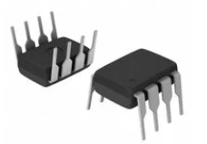 | 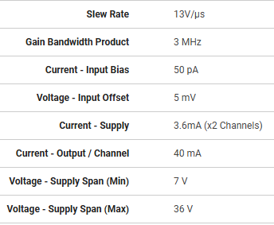

Part 1 Summing Amplifier
Compute the voltages and currents in the

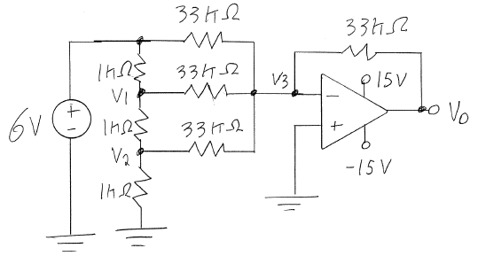
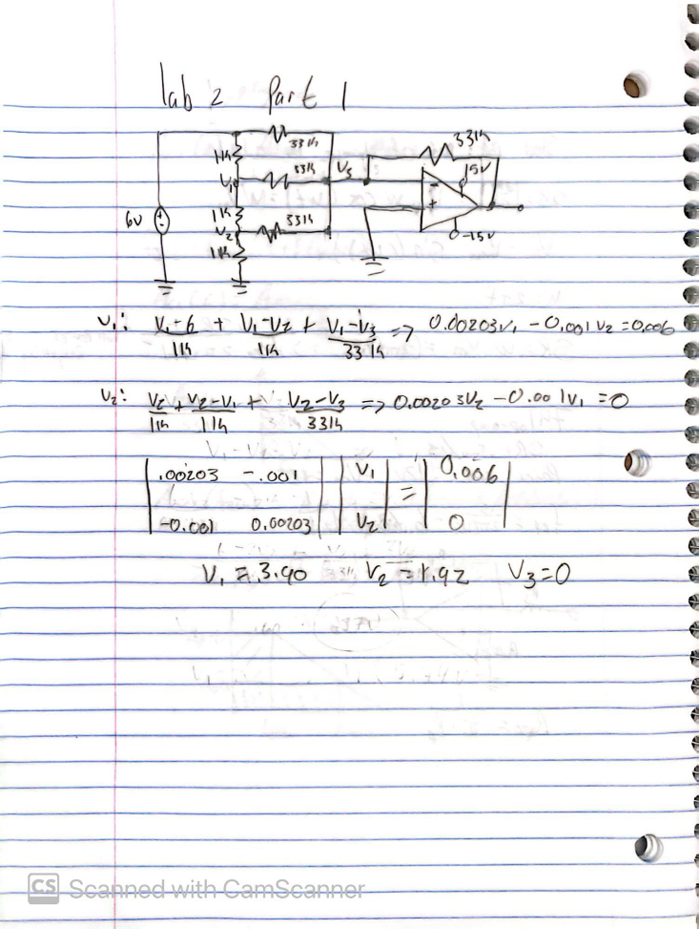
- Analyze the voltages in the three nodes, V1, V2, and V3. Assume V3 = 0

Measured
- Build the circuit.
- Measure the voltages and the nodes.
V1=3.907
V2=1.919
V3=0.003
V0=-11.79
- Does V3 equal to 0 as it should for an ideal op-amp? Explain any difference.
V3 is about 0. There is a slight difference in the internal components of the op-amp. Ideally the difference between the negative and the positive ends should be 0 meaning V3 that is going into the negative end of the op-amp and the positive end going to ground should result in v3 having 0volts just like you would get when you measure ground.

Part 2 Differential Amplifier
Setup the following circuit using any resistor.
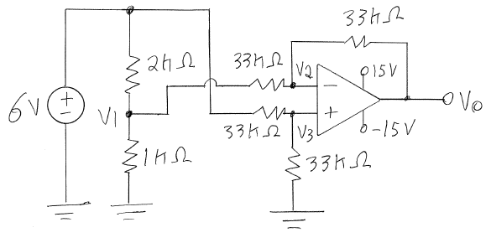
- Analyze the voltages in the three nodes, V1, V2, and V3.
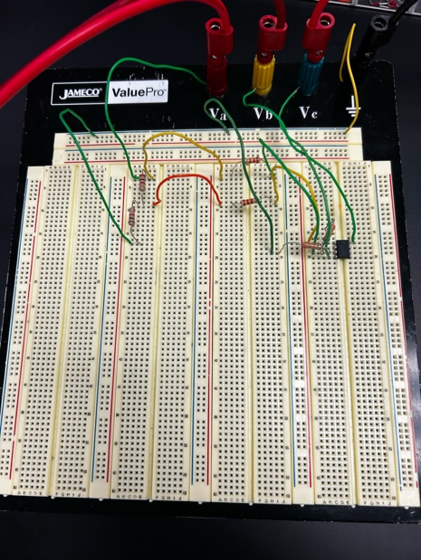
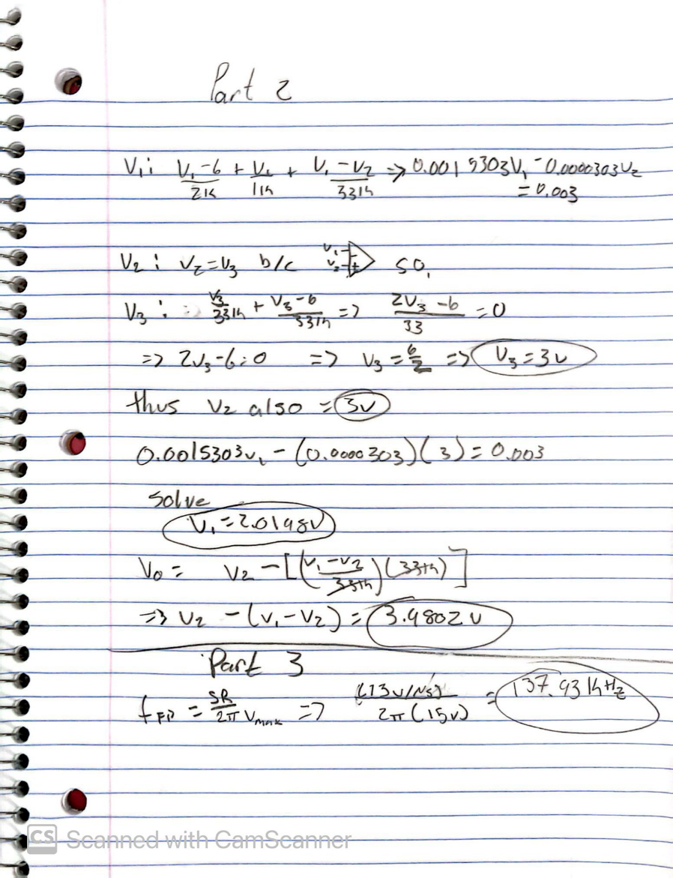
- Build the circuit.
- Measure the voltages and the nodes.
V1=2.014
V2=3.006
V3=3.006
Vo=4.003

- Does V1 follow a perfect voltage divider between the 2K and 1K resister (v1 = 2)? If not, explain why.
Not fully since there is a small tolerance within the resistor that can impact the voltage. The op-amp also inputs some sort of leakage that causes an offset.

- How can we change the circuit so that V1 is closer to 2 volts and not less.
Maybe use a slightly bigger resistor like 1.02 instead the of the 1k resistor.

Part 3 Slew rate, break frequency, and gain-bandwidth product
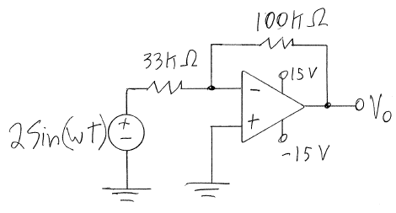
- Compute the Full Power frequency from the slew rate and the +/- 15V we are using to power the op-amp. The data sheet is on the top of this document.
In the previous image in part 2
- Build the circuit.
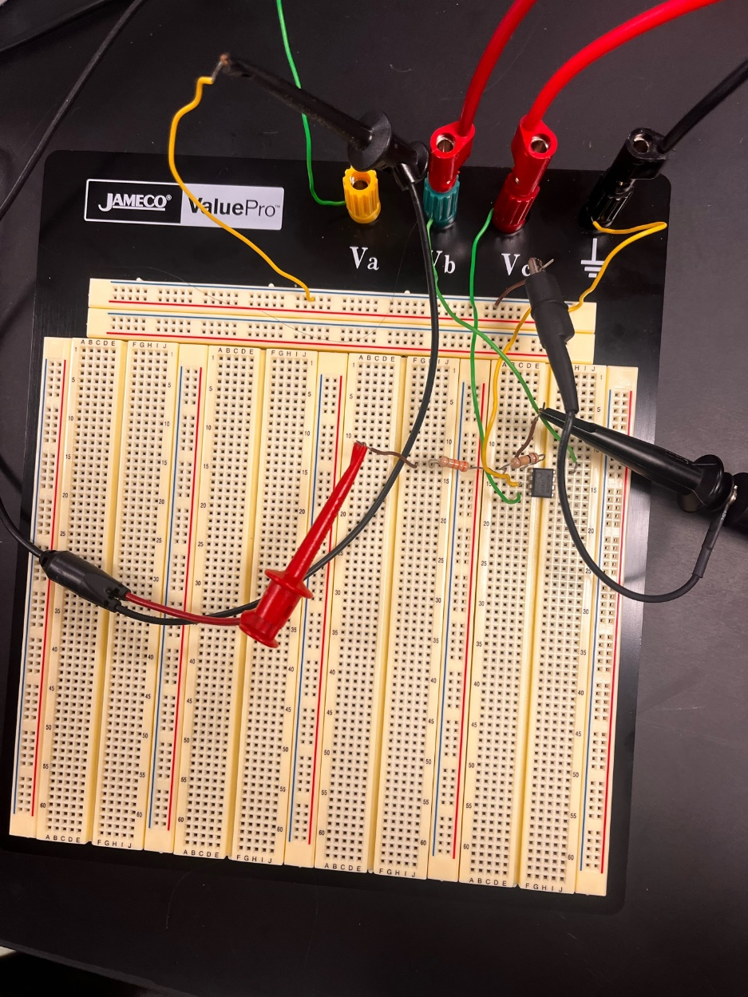

- Connect the function generator to the input and create a signal with a frequency of 100 Hz and amplitude of 2 volts.
- Connect the output, Vo, to the oscilloscope and display the output signal. It should have the same frequency but an amplitude of 6 volts.

- Compute the closed loop Break frequency using the equation below and the Gain-Bandwidth Product in the data sheet. Recall the Gain-Bandwidth Product = closed loop gain * closed loop break frequency both at 0 frequency.
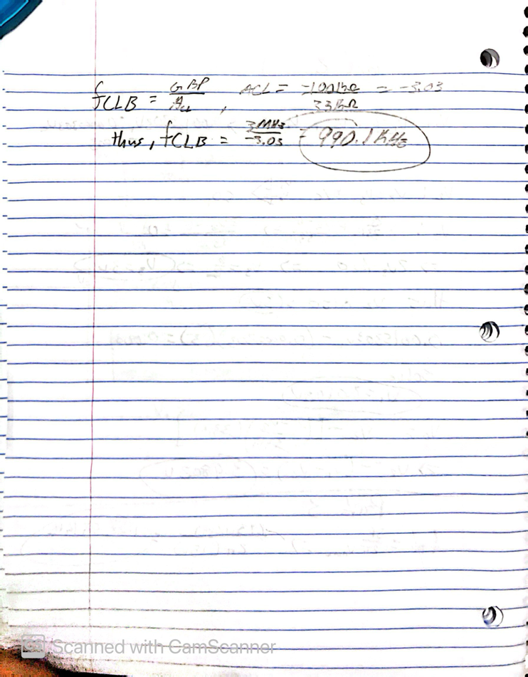
990.1KHz
- Measure the break frequency by increasing the frequency of the input signal until you notice the amplitude of the output begins to drop.
270KHz
- Explain any difference.
Our system was not working correctly. The professor also tried fixing it but it was just not working out correctly

- At that break frequency measure the phase angle between the input and output signals.
Max input is 5 vrms, anything else is either too much or too little.
It should be 150 but we found
144

